Display and Test

At first, I divided the entire game program into two parts, one is the main part of the game, and the other is the sprite class of the game. The main loop of the game is executed in the main part, such as creating a game clock, setting the refresh frequency, monitoring the event, and detecting the collision. The sprite class file mainly defines the attributes of the bullet, the player plane and the enemy planes and sets the condition judgment, such as speed, judgment of borders and bullets and enemy planes, etc.

Second, I want to display the game’s picture.

Start

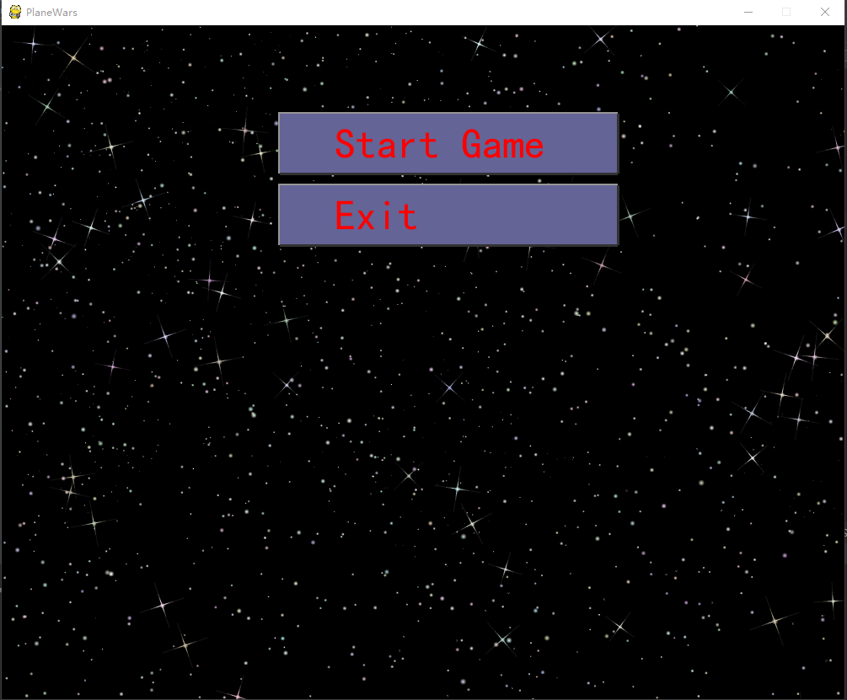

When you see the interface, you can click the start button and

start playing game.

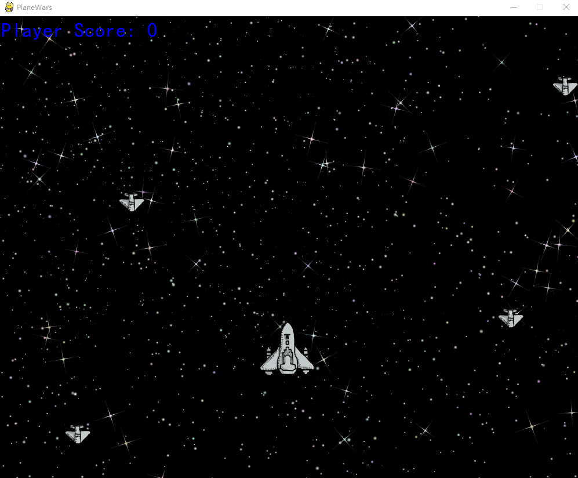

When starting the game, you can use W.S.A.D to control the plane move up, move down, move left and move right. And you can press the Space button on keyboard to shoot the bullets and destroy the enemies. When you destroy one enemy plane, you can get one score.

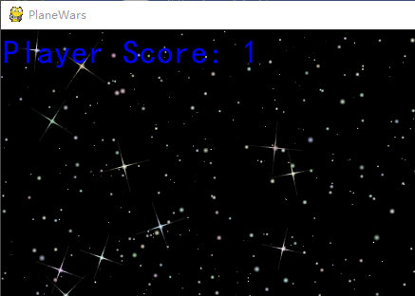

When you die, the interface will change, and you can see two buttons, one is restart, the other is exit.

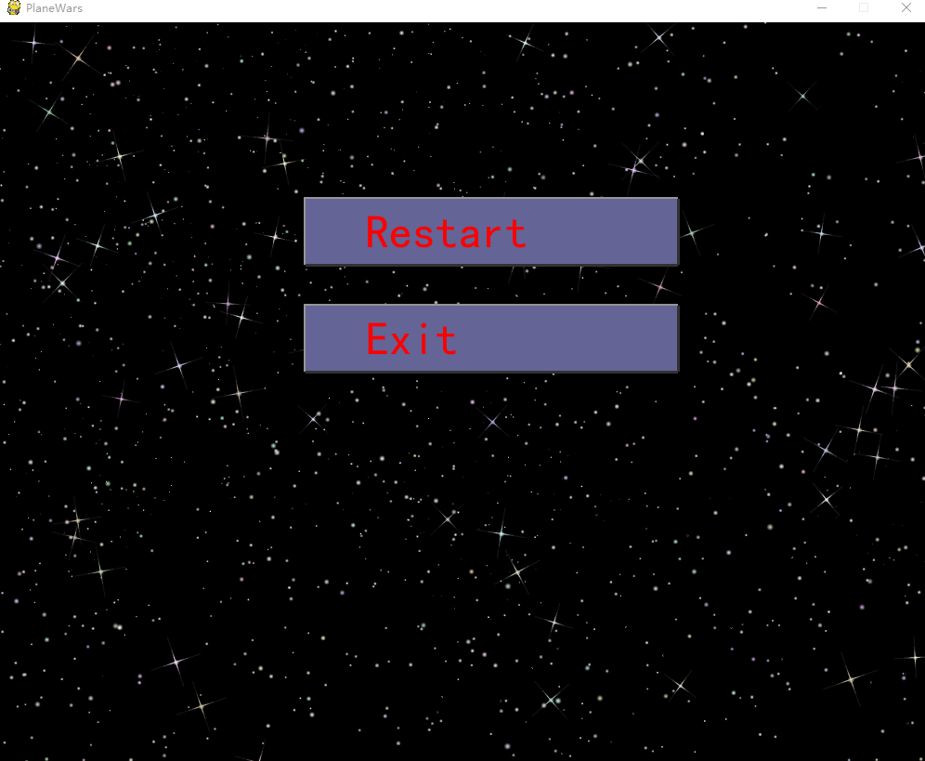

Test

I have successfully run the game for more than 100 times, every time I can play successfully and there is no problem, so I think this game has passed the test.